Lab 2: Files and Permissions CA percentage: 1%

- Answer all of the following questions. Questions are given in bold italics.
- Save all your answers in a file named YourFirstNameYourLastName.doc (or the appropriate file extension). Upload this file to Blackboard. Do not compress the file (e.g. .zip).

- Create a directory called Lab2 in your home directory. What is the command you used to create this directory? mkdir Lab2

- Change the current directory to ~/Lab2
Create a file named MyFile.txt. Edit this file so it contains one line of text: your full name. Explain how you did this. Cd Lab2, nano MyFile.txt

- Change the file permissions on the file you just created to the following:
  - –rwxrw-r-x
What command(s) did you run to achieve this? Describe what these file permissions mean. Chmod u+rwx, g+rw, a+rw MyFile.txt
U+rwx means a user has read, write and execute privileges in this file
G+rw means the group has read and write but no execute
A+rw means the group has read and write but no execute

- Create files named FileA, FileB, and FileC in the ~/Lab2 directory. List the commands you used. Touch FileA.txt, touch FileB.txt, touch FileC.txt

- Assign the following permissions to the files you just created. List the commands you use. Explain the effect of each set of file permissions.

- FileA: -rw---x—x
Chmod u=rw, g=x,a=x
- FileB: -r--r--r—
Chmod u=r,g=r,a=r
- FileC: -rwx------
Chmod u=rwx,g=,x=

- Create a file named firstscript.sh containing the following.
#!/bin/bash
echo "Hello $USER"
echo "Today is ";date
echo "Number of user/users logged in : " ; who | wc -l
echo "Calendar"
cal
exit 0

Change the file permissions to -rwx------. Run the script. What does it output?
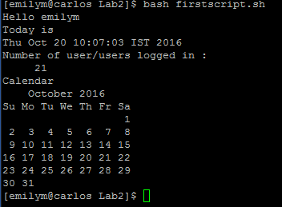

Note: who outputs a list of all the users that are logged in, this is pipped to the wc -l (Word count) command which counts the lines of text and outputs the Number of users that are logged in.

- Write a script to display the following:

Hello! The currently logged in user is:
yourusername
Here’s a list of all the users logged in:
List of all logged in users…
The current directory is:
The current directory path

Note: Think back to commands we used last week.

List the contents of your script. (Use either nano or cat)

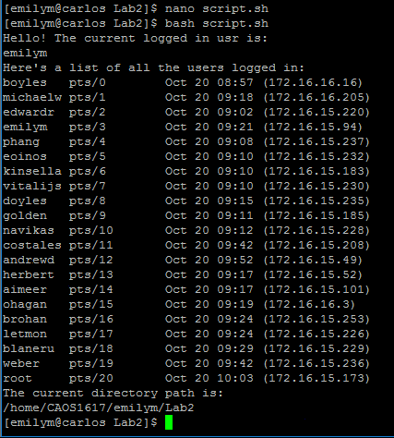

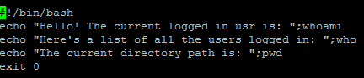
Once you have finished this lab continue to practice with the commands you have learned. Become as familiar as possible with these command as you will be expected to know them for later labs.
Note: Research on the Internet for solutions to any questions you cannot answer or commands you are unsure of.

